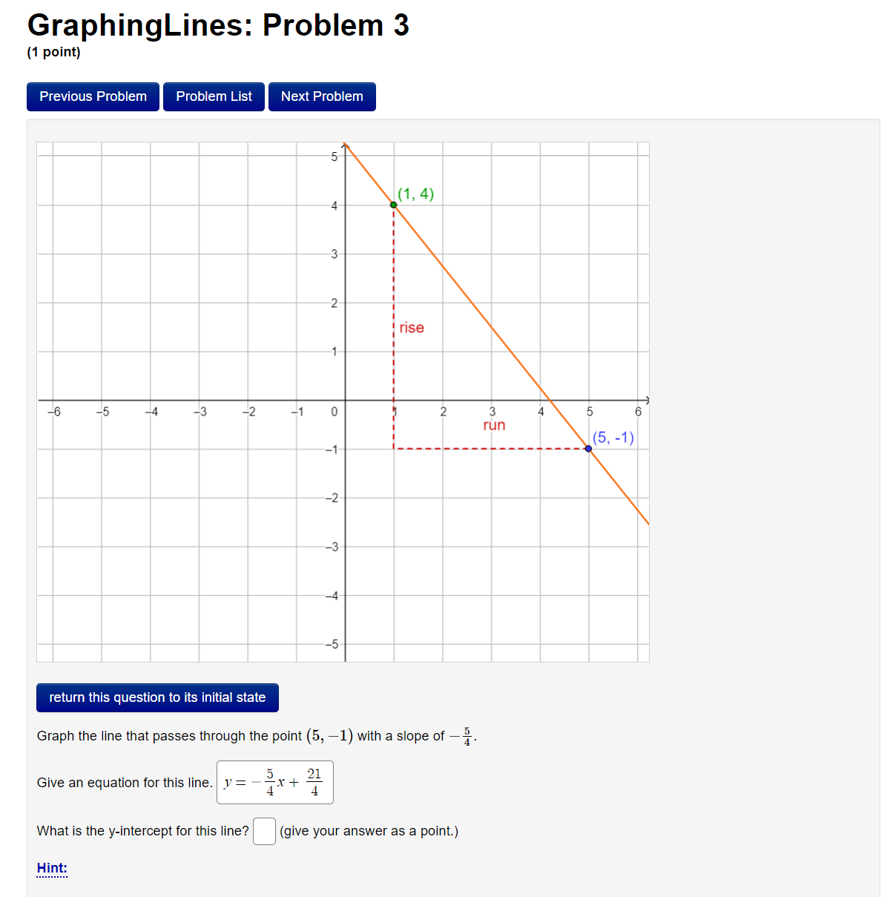

y intercept is (0, 5.25)
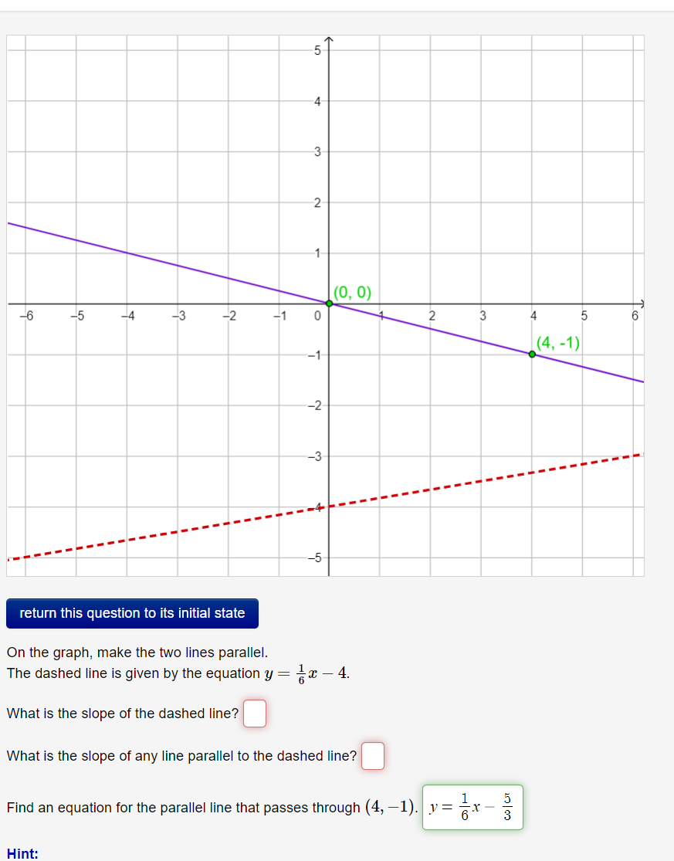
The equation of a line is given by y = mx + b where m is the slope and b the y intercept. Therefore, the slope of the dashed line given by y = 1/6 x – 4 is 1/6
Parallel lines have the save slope. Therefore, the slope of any line parallel to the dashed line is 1/6
The equation of the parallel line passing through (4, -1) will be calculated as follows:
slope = 1/6
$\frac{y-(-1)}{x-4}$ = $\frac{1}{6}$
6 (y + 1) = 1 (x – 4)
6y + 6 = x – 4
6y = x – 4 – 6
6y = x – 10
y = 1/6 x – 10/6
y = 1/6 x – 5/3
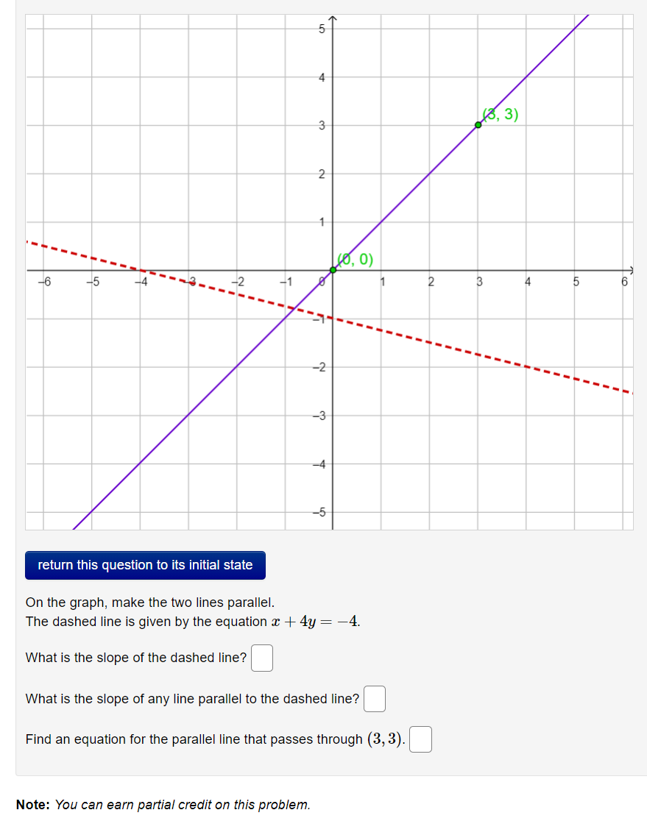

Given that the equation of the dashed line is x + 4y = -4
It can be arranged in the form of y = mx + b
4y = -x – 4
y = -1/4x – 4/4
y = -1/4x – 1
The slope of the dashed line is -1/4
The slope of any line parallel to the dashed line is -1/4
The equation of a parallel line that passes through (3, 3) is given by:
slope = -1/4
$\frac{y-3)}{x-3}$ = $\frac{-1}{4}$
4(y - 3) = -1 (x – 3)
4y - 12 = -x + 3
4y = -x + 3 + 12
4y = -x + 15
y = -1/4 x – 15/4

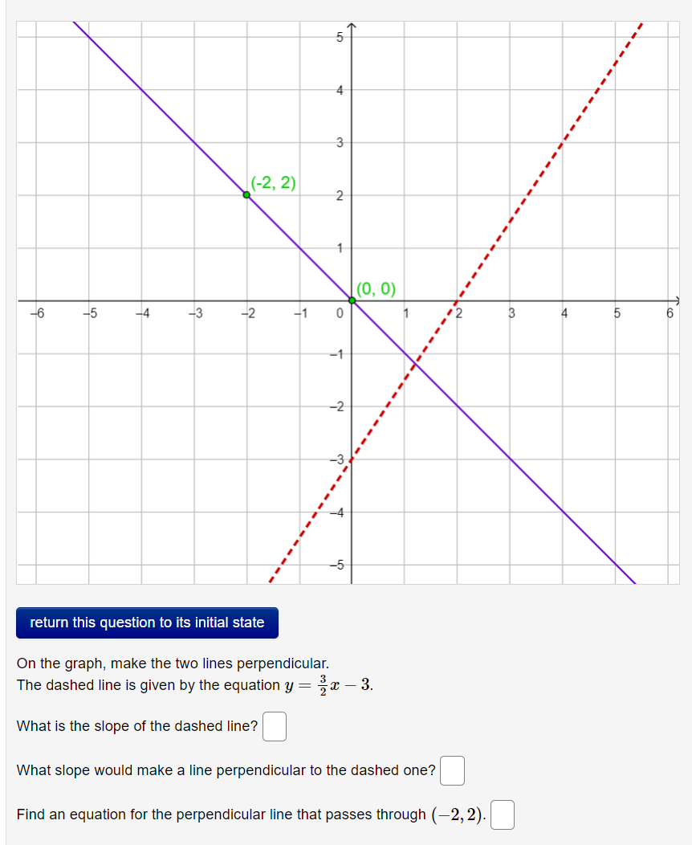
Since the equation of the dashed line is y = 3/2 x – 3, the slope is 3/2
The slopes of two perpendicular lines are negative reciprocals of each other. Therefore, the slope, the slope of a line perpendicular to the dashed one is -2/3
The equation for the perpendicular line passing through (-2, 2) is given by
slope = -2/3
$\frac{y-2}{x-(-2)}$ = $\frac{-2}{3}$
3(y - 2) = -2 (x +2)
3y - 6 = -2x - 4
3y = -2x -4 + 6
3y = -2x +2
y = -2/3 x + 2/3

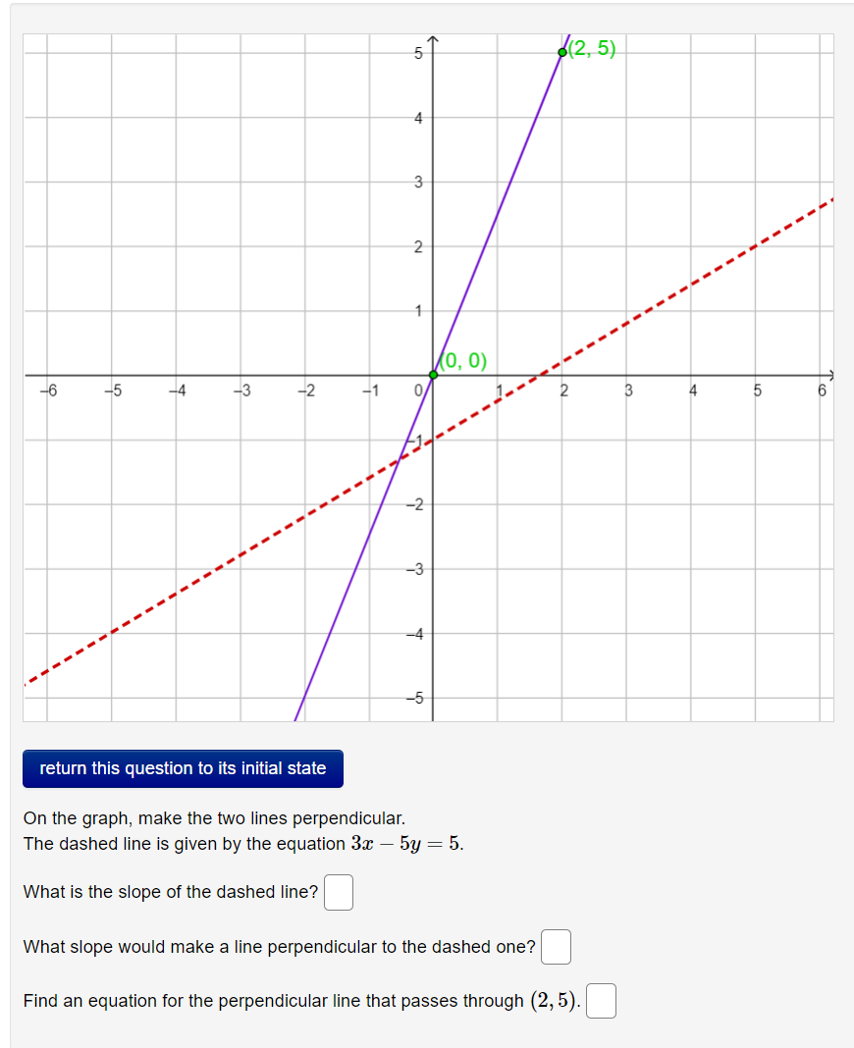

The equation of the dashed line is rearranged into the form y = mx + b
-5y = -3x + 5
5y = 3x – 5
y = 3/5 x – 5/5
y = 3/5 x – 1
The slope of the dashed line is 3/5
The slopes of two perpendicular lines are negative reciprocals of each other. Therefore, the slope, the slope of a line perpendicular to the dashed one is -5/3
The equation for the perpendicular line passing through (2, 5) is given by
slope = -5/3
$\frac{y-5}{x- 2)}$ = $\frac{-5}{3}$
3(y - 5) = -5 (x -2)
3y - 15 = -5x + 4
3y = -5x + 4 + 15
3y = -5x +19
y = -5/3 x + 19/3

